Student Database


By
Rakesh S Shetty
Sagar M Ayi
Ramesh Sidaray Mudalagi

Introduction

There are no sectors in the world where we don’t need data , hence we face many difficulties in storing it and retrieving in an efficient manner , therefore with the help of computer programming we can overcome these problems. The following program aims to solve it in a small scale, such that its solution can be amplified to the required scale.

There are many ways of accessing the database, but the parameters to choose the methods are, time and efficiency. Therefore, we should choose a method, such that, it should yield the required result in less amount of time with more efficiency. Here, in this scenario we have chosen to solve it using doubly linked list.

Problem Statement
Statement – Using c/c++/Java write a program that creates a binary file , which stores the details of the student , such as, name , usn , date of birth and address . Retrieve the stored data on the user’s request using doubly linked list and display it on the screen.

The main aim of this problem is to store the data of the student onto a binary file. Then, retrieve the data back from binary file using a doubly linked list.

The user can write a record of the student to a file, retrieve the record of a student from the binary file , delete a record from it and also modify it.

After the user makes any changes or during the same, he can even see the records present at that point of time in the file by using the list option provided

Inputs

The different kinds of inputs required for the processing are :

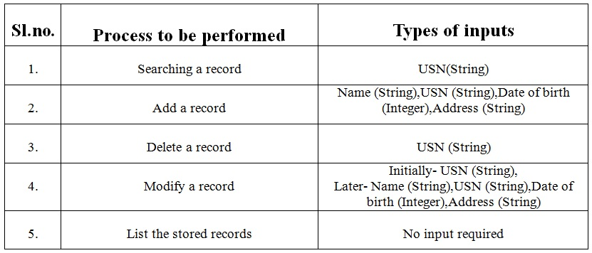
Output

The expected outputs for the corresponding processes are listed below in the table:

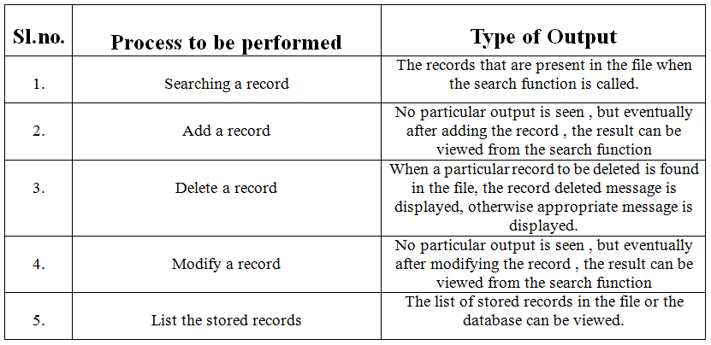

Flowchart

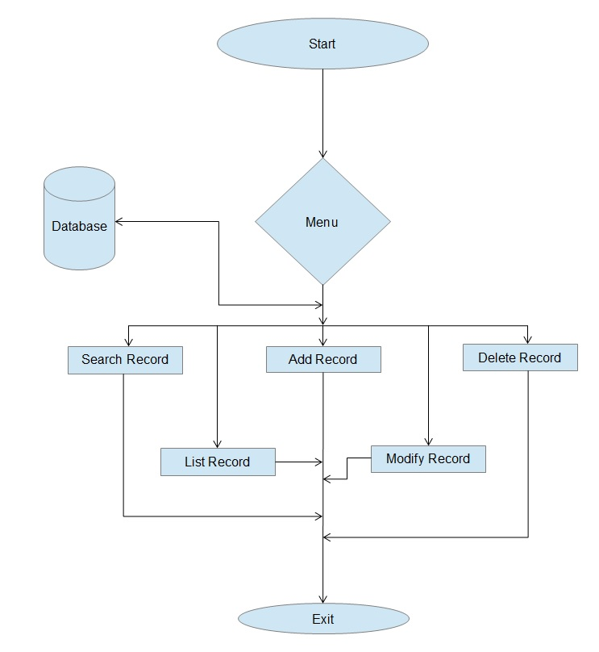

Implementation

Programming language / tools used :

C – for the implementation of the main logic and also for the purpose of interaction with gui to enable the proper functioning of the program

Python (Pygtk) - For the purpose of creating a graphical user interface (GUI) , as it would enable the user to access the features of the programme without facing much difficulty.

Programming environment used :

The development as well as the testing of the basic logic ,that is the c programme is done in unix environment . Also, the design , implementation and the testing of the GUI is also done in the same environment.

Programme source code:

#include<stdio.h>
#include<stdlib.h>
#include<string.h>
#include<ctype.h>

typedef struct
{
int dd;
int mm;
int yy;
}dob;

typedef struct
{
char name[20];
char usn[10];
dob db;
char adr[50];
}student;

//listrec( ) Function To list Records Present in the
void listrec(student std)
{
FILE *fp;
fp=fopen("stdbase1.dat","rb+");
if(fp==NULL)
{
printf("Cannot open a file\n");
exit(0);
}
printf("Student details are as follows\n");
printf("\nName\t\tUSN\t\tDate of Birth\t\tAddress\n");
printf("-------------------------------------------------------------------------------------------\n");
while(fread(&std,sizeof(std),1,fp)==1)
printf("%s\t\t%s\t\t%d/%d/%d\t\t%s\n",std.name,std.usn,std.db.dd,std.db.mm,std.db.yy,std.adr); fclose(fp);
}

//writerec( ) Function to Add the Records to the file
void writerec(student std)
{
FILE *fp;

fp=fopen("stdbase1.dat","ab+");
if(fp==NULL)
{
printf("Cannot open a file\n");
exit(0);
}
fwrite(&std,sizeof(std),1,fp);

fclose(fp);
}

//modifyrec( ) Function to Modify the Record(Particular Record) in the File
void modifyrec(char *argv,student std1)
{
FILE *fp;
int flag=1;
student std;
fp=fopen("stdbase1.dat","rb+");

if(fp==NULL)
{
printf("Cannot open a file\n");
exit(0);
}
fflush(stdin);
rewind(fp);

while(fread(&std,sizeof(std),1,fp)==1)
{
if(strcmp(std.usn,argv)==0)
{
flag=0;
fseek(fp,-sizeof(std),SEEK_CUR);
fwrite(&std1,sizeof(std1),1,fp);

}
//else
//fwrite(&std1,sizeof(std1),1,fp);
}
if(flag==1)
printf("Requested USN Not found");
else
printf("Modified");

fclose(fp);
}

//delerec( ) Function to Delete a Particulr record in the file
void delerec(char *argv)
{
FILE *fp,*ft;
int flag=1;
student std;
fp=fopen("stdbase1.dat","rb+");
if(fp==NULL)
{
printf("Cannot open a file\n");
exit(0);
}
ft=fopen("temp.dat","wb+");
if(fp==NULL)
{
printf("Cannot open a file\n");
exit(0);
}
rewind(fp);
while(fread(&std,sizeof(std),1,fp)==1)
{
if(strcmp(std.usn,argv)!=0)
{

fwrite(&std,sizeof(std),1,ft);
}

}

rewind(fp);
while(fread(&std,sizeof(std),1,fp)==1)
{
if(strcmp(std.usn,argv)==0)
{

flag=0;
}
}
fclose(ft);
fclose(fp);
system("rm stdbase1.dat");
system("mv temp.dat stdbase1.dat");

if(flag==0)
printf("Deleted successfuly");
else
printf("Enter the correct USN");

}

//Searchrec( ) Function to Search a Particulr Record inthe file
void Searchrec(char *argv)
{
FILE *fp;
int flag=1;
student std;

fp=fopen("stdbase1.dat","rb+");

if(fp==NULL)
{
printf("cannot open a file\n");
exit(0);
}

rewind(fp);
printf("\nYour requested Search is:\n");
printf("\nName\t\tUSN\t\tDate of Birth\t\tPlace\n");
printf("----------------------------------------------------------------------------------------------------------\n");

while(fread(&std,sizeof(std),1,fp))
{
if((strstr(std.usn,argv)))
{
flag=0;
printf("%s\t\t%s\t\t%d/%d/%d\t\%s\n",std.name,std.usn,std.db.dd,std.db.mm,std.db.yy,std.adr);
}

else if((strstr(std.name,argv)))
{
flag=0;
printf("%s\t\t%s\t\t%d/%d/%d\t\t%s\n",std.name,std.usn,std.db.dd,std.db.mm,std.db.yy,std.adr);
}

else if((strstr(std.adr,argv)))
{
flag=0;
printf("%s\t\t%s\t\t%d/%d/%d\t\t%s\n",std.name,std.usn,std.db.dd,std.db.mm,std.db.yy,std.adr);
}

}
if(flag==1)
printf("Not Found");

fclose(fp);

}

//convert( ) Function to Convert from String( argv ) to integer format
int convert(char *s)
{
int num=0,i=0;
while(s[i])
{
num=num*10+s[i]-'0';
i++;
}
return (num);
}
//main function( )

int main(int argc, char *argv[])
{
student std,std1;
if(!strcmp(argv[1],"-a"))
{
strcpy(std.name,argv[2]);
strcpy(std.usn,argv[3]);
std.db.dd=convert(argv[4]);
std.db.mm=convert(argv[5]);
std.db.yy=convert(argv[6]);
strcpy(std.adr,argv[7]);
writerec(std);
}
else if(!strcmp(argv[1],"-l"))
listrec(std);

else if(!strcmp(argv[1],"-m") )
{

strcpy(std1.name,argv[3]);
strcpy(std1.usn,argv[4]);
std1.db.dd=convert(argv[5]);
std1.db.mm=convert(argv[6]);
std1.db.yy=convert(argv[7]);
strcpy(std1.adr,argv[8]);
modifyrec(argv[2],std1);
}
else if(!strcmp(argv[1],"-d"))

delerec(argv[2]);

else if(!strcmp(argv[1],"-s"))
Searchrec(argv[2]);

return (0);

}

// End of programme

Source code for GUI:

import pygtk
pygtk.require('2.0')
import gtk
import os
# -------------------------

class TextViewExample:

def close_application(self, widget):
gtk.main_quit()

def __init__(self,wid):
wind4 = gtk.Window(gtk.WINDOW_TOPLEVEL)

wind4.set_title("R N S Institue Of Technology")
wind4.set_border_width(5)
wind4.set_size_request(400, 400)
wind4.set_resizable(True)

box1 = gtk.VBox(False, 0)
wind4.add(box1)
box1.show()

box2 = gtk.VBox(False, 10)
box2.set_border_width(10)
box1.pack_start(box2, True, True, 0)
box2.show()

sw = gtk.ScrolledWindow()
sw.set_policy(gtk.POLICY_AUTOMATIC, gtk.POLICY_AUTOMATIC)
textview = gtk.TextView()
textbuffer = textview.get_buffer()

sw.add(textview)
sw.show()
textview.show()

box2.pack_start(sw)

infile = open(wid, "r")

if infile:
string = infile.read()
infile.close()
textbuffer.set_text(string)

wind4.show()

def main3():
gtk.main()

return 0
#--------------------------

def label_box(parent,label_text):
# Create box for xpm and label
box1 = gtk.HBox(False, 0)

# Create a label for the button
label = gtk.Label(label_text)
label.set_justify(gtk.JUSTIFY_CENTER)

box1.pack_start(label, True, False, 50)

label.show()
return box1

class gui:
def mod_dest(self,widget,widget1):
widget1.destroy()

def del_dest(self,widget,widget1):
widget1.destroy()

def search_call(self,widget,entry_txt):
etry_search=entry_txt.get_text()
print "Search for %s \n" % etry_search
os.system("./a.out -s %s > searched.txt" % etry_search)

fobj=open("searched.txt","r")
for i in range(0,6):
string2=fobj.readline()
if(string2=="Not Found"):
#self.l7.set_text(string2)
title="R N S Institute of Technology"
message="<b>Search Not found.</b>\n<i>Enter your search keyword properly</i>\n<i><b>Note:</b></i>\nDon't Enter the<b> Date of Birth</b>\nas your search."
dialog = gtk.MessageDialog(None,
gtk.DIALOG_MODAL,
type=gtk.MESSAGE_ERROR,
buttons=gtk.BUTTONS_OK)
dialog.set_markup("<b>%s</b>" % title)
dialog.format_secondary_markup(message)
dialog.run()
dialog.destroy()
else:
TextViewExample("searched.txt")
main3()

fobj.close()

def list_call(self,widget):

os.system("./a.out -l > list.txt")
TextViewExample("list.txt")
main3()

def mod_call_final(self,widget,usn_mod,name,usn,dob,add):
name1 = name.get_text()
usn1 = usn.get_text()
dob1 = dob.get_text()
add1 = add.get_text()

command="./a.out -m %s %s %s %s %s > modified.txt" %(usn_mod,name1,usn1,dob1,add1)
os.system(command)
#fobj=open("modified.txt","r")
#string1=fobj.readline()
#self.l5.set_text(string1)
#fobj.close()

fobj=open("modified.txt","r")
for i in range(0,1):
string2=fobj.readline()
if(string2=="Requested USN Not found"):
#self.l7.set_text(string2)
title="R N S Institute of Technology"
message="<b>Requested USN Not found.</b>\nNote:\nEnter the USN properly in the \n<b><i>previous window,</i></b>\nto Modify the Record. "
dialog = gtk.MessageDialog(None,
gtk.DIALOG_MODAL,
type=gtk.MESSAGE_ERROR,
buttons=gtk.BUTTONS_OK)
dialog.set_markup("<b>%s</b>" % title)
dialog.format_secondary_markup(message)
dialog.run()
dialog.destroy()
else:
title="R N S Institute of Technology"
message="<b><i>Requested Record is updated successfully.</i></b><i>Thank you!!..</i>"
dialog = gtk.MessageDialog(None,
gtk.DIALOG_MODAL,
type=gtk.MESSAGE_INFO,
buttons=gtk.BUTTONS_OK)
dialog.set_markup("<b>%s</b>" % title)
dialog.format_secondary_markup(message)
dialog.run()
dialog.destroy()
fobj.close()

def add_call(self,widget,name,usn,dob,add):
name1 = name.get_text()
usn1 = usn.get_text()
dob1 = dob.get_text()
add1 = add.get_text()

command="./a.out -a %s %s %s %s > added.txt" %(name1,usn1,dob1,add1)
os.system(command)
#self.l6.set_text("Added successfully...")

title="R N S Institute of Technology"
message="<i>Thank you!!</i>\n\n<b><i>Your Recorded is Added successfully.</i></b>"
dialog = gtk.MessageDialog(None,
gtk.DIALOG_MODAL,
type=gtk.MESSAGE_INFO,
buttons=gtk.BUTTONS_OK)
dialog.set_markup("<b>%s</b>" % title)
dialog.format_secondary_markup(message)
dialog.run()
dialog.destroy()

#TextViewExample("added.txt")
#main3()

def del_call(self,widget,usn):
usn_del = usn.get_text()
print "USN to be Deleted %s \n" % usn_del

os.system("./a.out -d " + usn_del + " >deleted.txt ")
fobj=open("deleted.txt","r")
for i in range(0,1):
string2=fobj.readline()
if(string2=="Enter the correct USN"):
#self.l7.set_text(string2)
title="R N S Institute of Technology"
message="<b>Requested USN Not found.</b>\nNote:\nEnter the USN properly\nto delete the Record."
dialog = gtk.MessageDialog(None,
gtk.DIALOG_MODAL,
type=gtk.MESSAGE_ERROR,
buttons=gtk.BUTTONS_OK)
dialog.set_markup("<b>%s</b>" % title)
dialog.format_secondary_markup(message)
dialog.run()
dialog.destroy()
else:
title="R N S Institute of Technology"
message="<b><i>Requested Record is Deleted successfully.</i></b>"
dialog = gtk.MessageDialog(None,
gtk.DIALOG_MODAL,
type=gtk.MESSAGE_INFO,
buttons=gtk.BUTTONS_OK)
dialog.set_markup("<b>%s</b>" % title)
dialog.format_secondary_markup(message)
dialog.run()
dialog.destroy()
fobj.close()

#TextViewExample("deleted.txt")
#main3()

def mod_call1(self,widget,usn):
usn_mod = usn.get_text()
print "USN to be modified %s \n" % usn_mod
wind=gtk.Window()
wind.set_position(gtk.WIN_POS_CENTER)
wind.set_size_request(375,275)
wind.set_title("Modify Record")
wind.set_border_width(20)

table = gtk.Table(27, 27, False)
wind.add(table)

l12=gtk.Label("Enter Details to Modify:")
l13=gtk.Label("-------------------------")

l1=gtk.Label("Name")

l1.set_justify(gtk.JUSTIFY_LEFT)
l1.show()
etry_search = gtk.Entry()

etry_search.show()

l2=gtk.Label("USN")

l2.set_justify(gtk.JUSTIFY_LEFT)
l2.show()

etry_search2 = gtk.Entry()

etry_search2.show()

l3=gtk.Label("Date Of Birth")

l3.set_justify(gtk.JUSTIFY_LEFT)
l3.show()
etry_search3 = gtk.Entry()

etry_search3.show()

l4=gtk.Label("Address")

l4.set_justify(gtk.JUSTIFY_LEFT)
l4.show()
self.l5 = gtk.Label()
self.l5.show()
etry_search4 = gtk.Entry()

etry_search4.show()

button1 = gtk.Button()

button1.connect("clicked", self.mod_call_final,usn_mod,etry_search,etry_search2,etry_search3,etry_search4)

box1=label_box(wind,"Modify")
button1.add(box1)

button1.show()

button2=gtk.Button()
button2.connect("clicked", self.mod_dest,wind)
box1=label_box(wind,"Exit")
button2.add(box1)

button2.show()

table.attach(l12,2,5,0,2)
table.attach(l13,2,5,3,5)
table.attach(l1,1,2,5,7)
table.attach(etry_search,3,5,5,7)
table.attach(l2,1,2,9,11)
table.attach(etry_search2,3,5,9,11)
table.attach(l3,1,2,13,15)
table.attach(etry_search3,3,5,13,15)
table.attach(l4,1,2,17,19)
table.attach(etry_search4,3,5,17,19)
table.attach(button2,1,2,21,23)
table.attach(button1,3,5,21,23)
table.attach(self.l5,3,5,25,27)
table.show()

wind.show_all()

def search(self, widget, data=None):

wind=gtk.Window()
wind.set_position(gtk.WIN_POS_CENTER)

wind.set_title("Search Record")
wind.set_border_width(40)
vbox=gtk.VBox(False,0)
wind.add(vbox)

hbox=gtk.HBox(False,0)
l1=gtk.Label("Search")
hbox.pack_start(l1,False,False,0)
l1.set_justify(gtk.JUSTIFY_LEFT)
l1.show()
etry_search = gtk.Entry()
hbox.pack_start(etry_search,True,False,0)
etry_search.show()
vbox.add(hbox)

hbox.show()
self.l7 = gtk.Label()

self.l7.show()
textabc="Note:Don't Enter the Date of Birth"
l14=gtk.Label("%s" % textabc)
vbox.pack_start(l14,False,False,0)
l14.show()

button1 = gtk.Button()
button1.connect("clicked", self.search_call,etry_search)

box1=label_box(wind,"Search")

button1.add(box1)

vbox.pack_start(button1,0,10,15)
vbox.pack_start(self.l7,0,0,5)
box1.show()
button1.show()

vbox.show()
wind.show()

def add(self, widget, data=None):
wind=gtk.Window()
wind.set_position(gtk.WIN_POS_CENTER)

wind.set_size_request(375,325)
wind.set_border_width(100)
wind.set_title("Add Record")
wind.set_border_width(50)

table = gtk.Table(27, 27, False)
wind.add(table)

l12=gtk.Label("Enter your Deatails:")
l13=gtk.Label("-------------------------")

l1=gtk.Label("Name")

l1.set_justify(gtk.JUSTIFY_LEFT)
l1.show()
etry_search = gtk.Entry()

etry_search.show()

l2=gtk.Label("USN")

l2.set_justify(gtk.JUSTIFY_LEFT)
l2.show()

etry_search2 = gtk.Entry()

etry_search2.show()

l3=gtk.Label("Date Of Birth")

l3.set_justify(gtk.JUSTIFY_LEFT)
l3.show()
etry_search3 = gtk.Entry()

etry_search3.show()

l4=gtk.Label("Address")

l4.set_justify(gtk.JUSTIFY_LEFT)
l4.show()
self.l6 = gtk.Label()
self.l6.show()
etry_search4 = gtk.Entry()

etry_search4.show()

button1 = gtk.Button()

button1.connect("clicked", self.add_call, etry_search,etry_search2,etry_search3,etry_search4)
#button1.connect("clicked", self.mod_dest,wind)
box1=label_box(wind,"Add")
button1.add(box1)

button1.show()
#vbox.show()

button2=gtk.Button()
button2.connect("clicked", self.mod_dest,wind)
box1=label_box(wind,"Exit")
button2.add(box1)

button2.show()

table.attach(l12,2,5,0,2)
table.attach(l13,2,5,3,5)
table.attach(l1,1,2,5,7)
table.attach(etry_search,3,5,5,7)
table.attach(l2,1,2,9,11)
table.attach(etry_search2,3,5,9,11)
table.attach(l3,1,2,13,15)
table.attach(etry_search3,3,5,13,15)
table.attach(l4,1,2,17,19)
table.attach(etry_search4,3,5,17,19)
table.attach(button2,1,2,21,23)
table.attach(button1,3,5,21,23)

table.attach(self.l6,3,5,26,27)

table.show()
wind.show_all()

def delete(self, widget, data=None):
wind=gtk.Window()
wind.set_position(gtk.WIN_POS_CENTER)
wind.set_size_request(300,200)
wind.set_border_width(150)
wind.set_title("Delete Record")
wind.set_border_width(20)
vbox=gtk.VBox(False,0)
wind.add(vbox)
hbox=gtk.HBox(False,0)

l14=gtk.Label("Record Will be Deleted from Database")
vbox.pack_start(l14,False,False,0)
l14.show()

l15=gtk.Label("------------------------------------")
vbox.pack_start(l15,False,False,0)
l15.show()

l1=gtk.Label("Enter the USN")
hbox.pack_start(l1,False,False,5)
l1.show()
etry_search = gtk.Entry()
hbox.pack_start(etry_search,False,False,5)
vbox.pack_start(etry_search,False,False,0)

#etry_search.set_border_width(50)
etry_search.show()
vbox.add(hbox)
hbox.show()
self.l8 = gtk.Label()

self.l8.show()
button1 = gtk.Button()
button1.connect("clicked", self.del_call, etry_search)
#button1.connect("clicked", self.del_dest,wind)
box1=label_box(wind,"Delete")
button1.add(box1)
vbox.pack_start(button1,False,True,0)
vbox.pack_start(self.l8,0,0,5)
box1.show()
vbox.show()
button1.show()
wind.show()
def mod1(self,widget,data=None):
wind=gtk.Window()
wind.set_position(gtk.WIN_POS_CENTER)
wind.set_size_request(300,150)
wind.set_title("Modify Record")
wind.set_border_width(20)
vbox=gtk.VBox(False,0)
wind.add(vbox)
hbox=gtk.HBox(False,0)

l14=gtk.Label("Record Will be modified in Database")
vbox.pack_start(l14,False,False,0)
l14.show()

l15=gtk.Label("------------------------------------")
vbox.pack_start(l15,False,False,0)
l15.show()

l1=gtk.Label("Enter the USN")
hbox.pack_start(l1,False,False,5)
l1.show()
etry_search = gtk.Entry()
hbox.pack_start(etry_search,False,False,5)
etry_search.show()
vbox.add(hbox)
hbox.show()
button1 = gtk.Button()
button1.connect("clicked", self.mod_call1, etry_search)
button1.connect("clicked", self.mod_dest,wind)
box1=label_box(wind,"Modify")

button1.add(box1)
vbox.pack_start(button1,False,False,0)
box1.show()
button1.show()
vbox.show()
wind.show()

def thk(self, widget,wind):
title="R N S Institute of Technology"
message="Keep your records safe with us\n(Maintaining Database)\n \n<i>Thank you! for sparing your precious\n time with us.</i>"
dialog = gtk.MessageDialog(wind,
gtk.DIALOG_MODAL,
type=gtk.MESSAGE_INFO,
buttons=gtk.BUTTONS_OK)
dialog.set_markup("<b>%s</b>" % title)
dialog.format_secondary_markup(message)
dialog.run()
dialog.destroy()

def about(self, widget, wind):
title="R N S Institute of Technology"
message="Keep your records safe with us\n(Maintaining Database)\n \n<i>Authors : \n\nRakesh Shetty,\n Sagar M Ayi and \n Ramesh Sidaray Mudalagi</i>"
dialog = gtk.MessageDialog(wind,
gtk.DIALOG_MODAL,
type=gtk.MESSAGE_INFO,
buttons=gtk.BUTTONS_OK)
dialog.set_markup("<b>%s</b>" % title)
dialog.format_secondary_markup(message)
dialog.run()
dialog.destroy()

def info(self, widget, wind):
title="R N S Institute of Technology"
message="Keep your records safe with us\n(Maintaining Database)\n \n<i>Authors : \n\nRakesh Shetty,\n Sagar M Ayi and \n Ramesh Sidaray Mudalagi</i>"
dialog = gtk.MessageDialog(wind,
gtk.DIALOG_MODAL,
type=gtk.MESSAGE_INFO,
buttons=gtk.BUTTONS_OK)
dialog.set_markup("<b>%s</b>" % title)
dialog.format_secondary_markup(message)
dialog.run()
dialog.destroy()

def __init__(self):

window = gtk.Window(gtk.WINDOW_TOPLEVEL)
window.set_title("Menu")
window.set_border_width(50)
window.set_size_request(250,450)
window.connect("destroy", lambda wid: gtk.main_quit())
window.connect("delete_event", lambda w,e: gtk.main_quit())
window.set_position(gtk.WIN_POS_CENTER)
vbox=gtk.VBox(False,0)
window.add(vbox)
vbox.show()

l10=gtk.Label("Student Database")
vbox.pack_start(l10,False,False,10)
l10.show()

l11=gtk.Label("--------------------------")
vbox.pack_start(l11,False,False,0)
l11.show()

#creating about button
button6 = gtk.Button()
button6.connect("clicked", self.about, window)
box6=label_box(window,"About app..")
button6.add(box6)
vbox.pack_start(button6,False,False,8)
box6.show()
button6.show()

#creating add button
button2 = gtk.Button()
button2.connect("clicked", self.add, "Add record")
box2=label_box(window,"Add record")
button2.add(box2)
vbox.pack_start(button2,False,False,8)
box2.show()
button2.show()

#creating search button
button1 = gtk.Button()
button1.connect("clicked", self.search, "Search record")
box1=label_box(window,"Search record")
button1.add(box1)
vbox.pack_start(button1,False,False,8)
box1.show()

button1.show()

#creating delete button
button3 = gtk.Button()
button3.connect("clicked", self.delete, "Delete record")
box3=label_box(window,"Delete record")
button3.add(box3)
vbox.pack_start(button3,False,False,8)
box3.show()
button3.show()
#creating modify button
button4 = gtk.Button()
button4.connect("clicked", self.mod1, "Modify record")
box4=label_box(window,"Modify record")
button4.add(box4)
vbox.pack_start(button4,False,False,8)
box4.show()
button4.show()

#creating list button
button5 = gtk.Button()
button5.connect("clicked", self.list_call)
box5=label_box(window,"List record")
button5.add(box5)
vbox.pack_start(button5,False,False,8)
box5.show()
button5.show()

#creating thank button
button10 = gtk.Button()
button10.connect("clicked", self.thk, window)
box10=label_box(window,"Thank You!!")
button10.add(box10)
vbox.pack_start(button10,False,False,8)
box10.show()
button10.show()

window.show()

def main():
gtk.main()

return 0

if __name__ == "__main__":
gui()
main()

Testing (Snapshots included)

Main Menu –

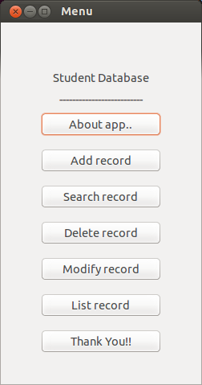

Add Menu-

a)Entering Details Here:
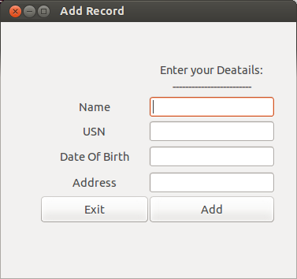

b) After adding the Record:

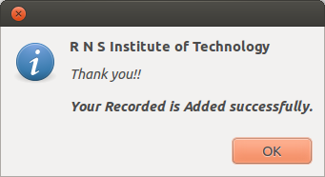

Search –

a)Enter your Search :

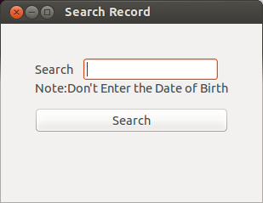

b)Successful search-

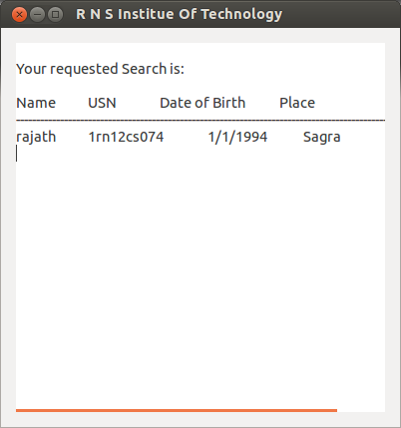

c)Unsuccessful search –
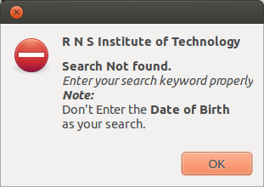

Delete-

a)Enter the USN to Delete:
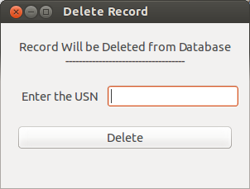

b)If USN not Found:

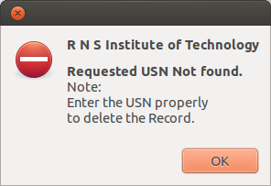

c)On Successful Deletion of the Record:

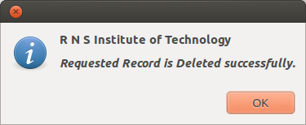

Modify –

a)Enter USN to Modify:

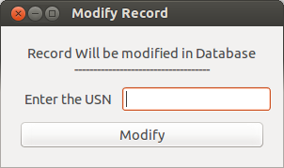

b)USN not Found:

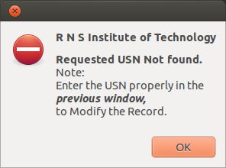

c)Modification(successfully modified):

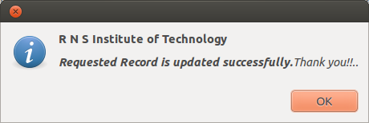

List –

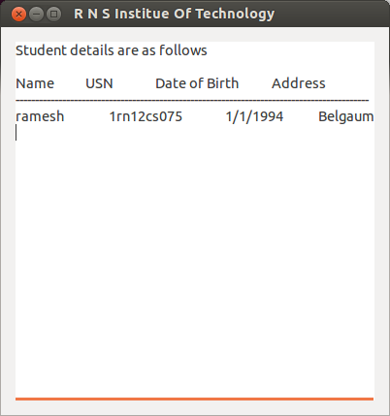

Conclusion

The given problem has been successfully solved using the basic principles of c programming , other languages also could have been used, but, ‘C’ language is better and more programmer friendly .

#Dude write some more conclusion text.

References

Websites-

http://www.pygtk.org/

Books –
“Let us C” by Yashwant Kanetkar
“C++ Complete Reference 4th Ediditon “ by Herbert Schildt

Special Thanks to-
Hemanth Sir
#Mr.Akash Hiremath(Student of 4th sem ‘A’ section)
#Mr. Sujay M (Student of 4th sem ‘C’ section)

